**LAB 7**

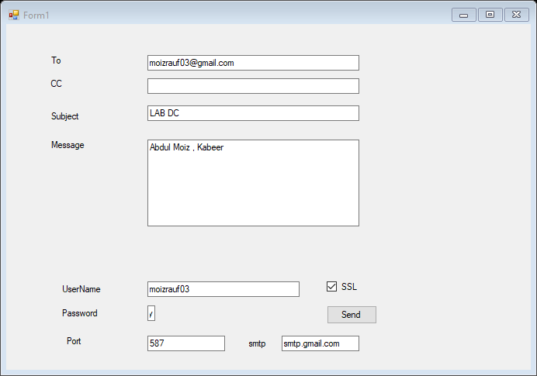

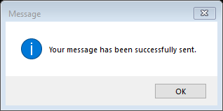

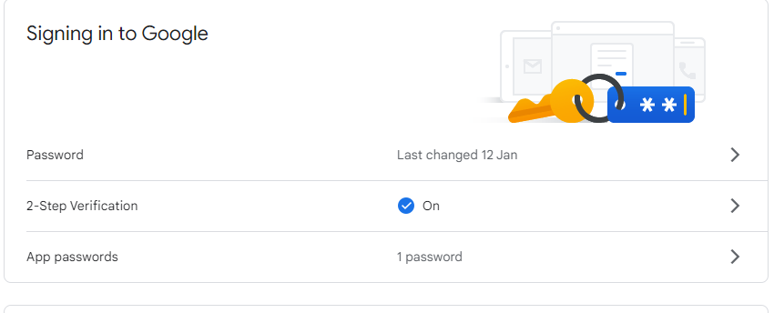

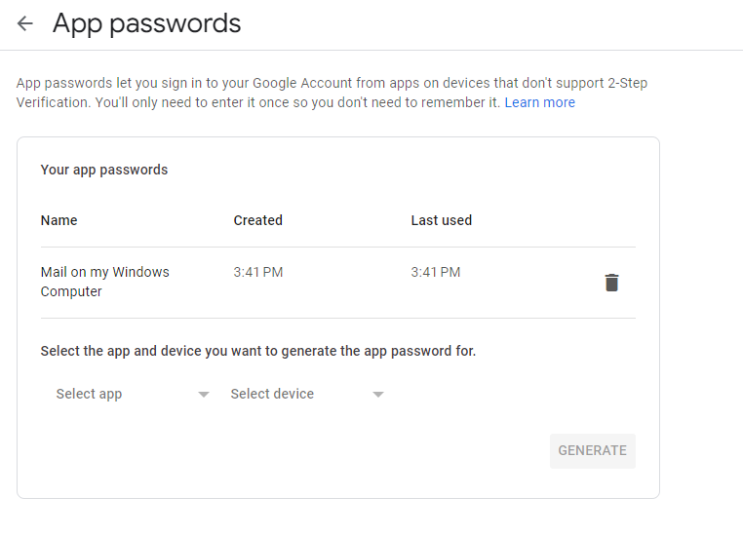

Mailed Received.

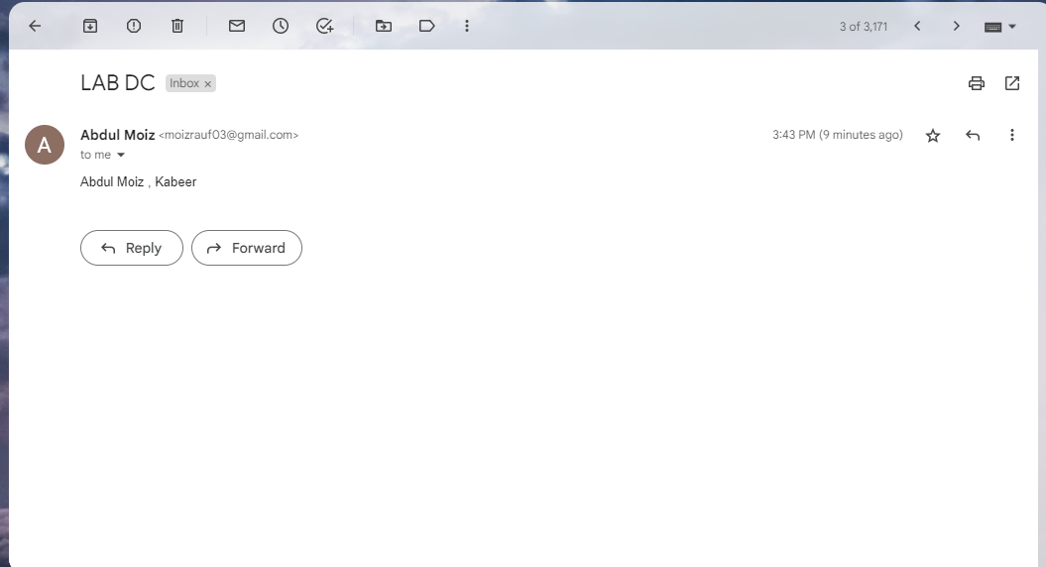

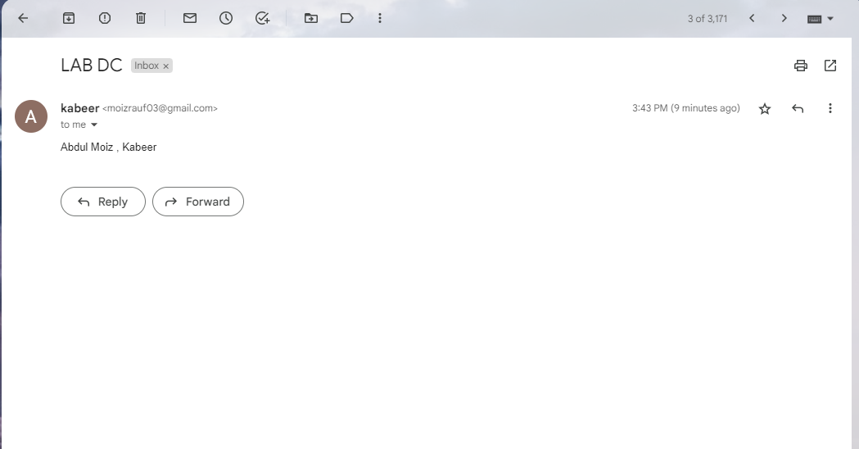

Code:

using System;

using System.Collections.Generic;

using System.ComponentModel;

using System.Data;

using System.Drawing;

using System.Linq;

using System.Text;

using System.Threading.Tasks;

using System.Windows.Forms;

using System.Net;

using System.Net.Mail;

namespace WindowsFormsApplication2

{

public partial class Form1 : Form

{

NetworkCredential login;

SmtpClient client;

MailMessage msg;

public Form1()

{

InitializeComponent();

}

private void label1_Click(object sender, EventArgs e)

{

}

private void button1_Click(object sender, EventArgs e)

{

//login to your mail server

NetworkCredential login = new NetworkCredential(txtUsername.Text, txtPassword.Text);

SmtpClient client = new SmtpClient(txtSmtp.Text);

client.Port = Convert.ToInt32(txtPort.Text);

client.EnableSsl = chkSSL.Checked;

client.Credentials = login;

MailMessage msg = new MailMessage { From = new MailAddress(txtUsername.Text + txtSmtp.Text.Replace("smtp.", "@"), "Abdul Moiz", Encoding.UTF8) };

msg.To.Add(new MailAddress(txtTo.Text));

if (!string.IsNullOrEmpty(txtCC.Text))

msg.To.Add(new MailAddress(txtCC.Text));

msg.Subject = txtSubject.Text;

msg.Body = txtMessage.Text;

msg.BodyEncoding = Encoding.UTF8;

msg.IsBodyHtml = true;

msg.Priority = MailPriority.Normal;

msg.DeliveryNotificationOptions = DeliveryNotificationOptions.OnFailure;

client.SendCompleted += new SendCompletedEventHandler(SendCompletedCallback);

string userstate = "Sending...";

//Send email async

client.SendAsync(msg, userstate);

}

private static void SendCompletedCallback(object sender, AsyncCompletedEventArgs e)

{

if (e.Cancelled)

MessageBox.Show(string.Format("{0} send canceled.", e.UserState), "Message", MessageBoxButtons.OK, MessageBoxIcon.Information);

if (e.Error != null)

MessageBox.Show(string.Format("{0} {1}", e.UserState, e.Error), "Message", MessageBoxButtons.OK, MessageBoxIcon.Information);

else

MessageBox.Show("Your message has been successfully sent.", "Message", MessageBoxButtons.OK, MessageBoxIcon.Information);

}

}}